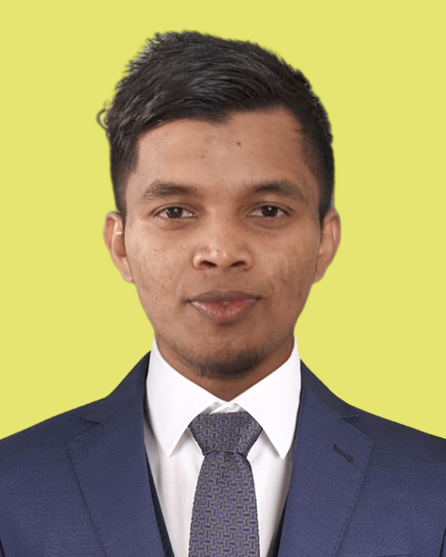

NAZMUS SAKIB
Aspiring IT Professional

Contact Information
- Email: ug2102066@cse.pstu.ac.bd | nazmussakib200224@gmail.com
- Phone: +8801741976660
- Location: Patuakhali, Bangladesh

Career Objective
A highly motivated and aspiring IT professional seeking a challenging entry-level position in the IT/Telecommunication sector. I am eager to apply my academic knowledge and technical skills in Data Entry, Computer Operations, and Web Development to contribute effectively to an organization's success and to foster my continuous professional growth in a dynamic environment.

Skills Profile
Technical Competencies:
- Web Development: HTML5 (Advanced), CSS3 (Advanced), JavaScript (Intermediate)
- Programming: C++ (Intermediate), Java (Intermediate)
- Databases: MySQL (Intermediate), Oracle (Familiar)
- Design: Graphic Design (Familiar)
- Data Management: Data Entry (Expert)

Additional Skills:
- Proficient in Microsoft Office Suite
- Strong problem-solving abilities
- Effective communication skills
- Team-oriented and collaborative
- Adaptable and quick learner

Portfolio Project
Personal Portfolio Website
- URL: https://nazmussakib66.netlify.app/
- Description: A dynamic personal portfolio website developed to showcase my full-stack web development projects, technical competencies, and blog. The site includes a detailed resume, contact information, and articles sharing insights on modern web development practices. This project demonstrates proficiency in front-end design, content management, and deployment.

Academic Qualifications
Bachelor of Science (BSc) in Computer Science & Engineering
- Patuakhali Science and Technology University
- Expected Graduation: 2027 (Currently Enrolled)
- Duration: 2022 - Present
Higher Secondary Certificate (HSC) - Science
- Syed Bazlul Haque College
- Passing Year: 2020
- Result: GPA 5.00 / 5.00
Secondary School Certificate (SSC) - Science
- Uttarkul Secondary School
- Passing Year: 2018
- Result: GPA 5.00 / 5.00

Personal Details
- Father's Name: Muhammad Rafiqul Islam
- Mother's Name: Mst. Shahida Khanom
- Date of Birth: May 24, 2002
- Gender: Male
- Nationality: Bangladeshi
- Religion: Islam
- Marital Status: Unmarried
- Blood Group: A+
- Permanent Address: Kachua, Baishari, Banaripara, Barishal - 8530

